Troop 713 Scout Leadership Positions
Duties and Responsibilities

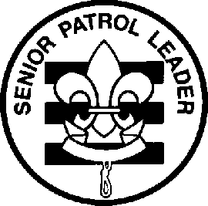 | 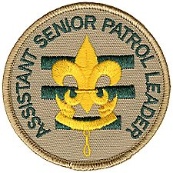 | 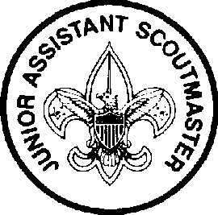 | 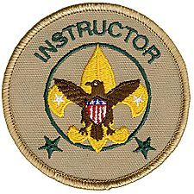 | 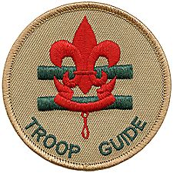 | 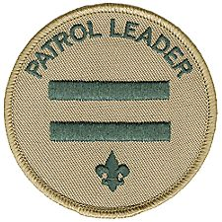 | 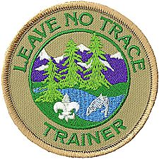
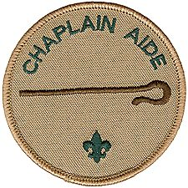 | 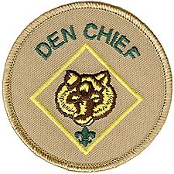 | 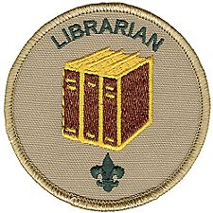 | 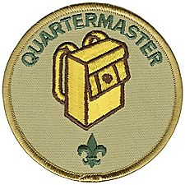 | 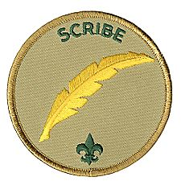 | 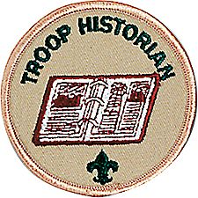 | 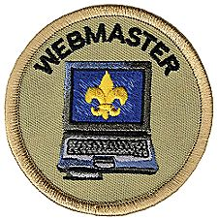

Leading the way... What does that mean?
Think about being a Cub Scout. You came to den meetings and did a lot of different and fun things. But who decided what to do and who planned the activities? The Den Leaders, right?
Sports teams are a lot of fun, too. But who decides who plays what position, who's on the starting lineup and when to substitute? The Coach, right?
There is one thing that makes Scouting different from all other youth groups. Do you know what it is?
Well, it is not the uniform. Every soccer, basketball, and baseball team has a uniform. It is not the fun activities. There are a lot of other things that are fun. And it certainly isn't cleaning dirty pots and pans on a campout.!!

What makes Scouting special is that YOU make the decisions!
That's right! YOU run the troop. Baden-Powell made it very plain in Aids to Scoutmastership when he wrote,
“The best progress is made in those Troops where power and responsibility are really put into the hands of the Patrol Leaders.”
This is real decision making power. And it's not just Patrol Leaders. All of the troop leadership positions have a hand in making the Troop run. As a troop leader you will:
Plan and run troop meetings,
Pick troop outings, where to camp, what to do,
Plan advancement opportunities for all troop members
Select High-Adventure programs
Determine troop policy
Help other Scouts along the trail to Eagle.
Sound cool? It really is! The adults are there to provide support but YOU will be making the decisions.
Because being a leader is more than just getting a patch. We have put together job descriptions for the troop leadership positions. They will give you an idea of what each job is all about and what you will be required to do.
Here's how to be considered for a position. First read the job descriptions, qualifications, and job responsibilities. Then decide what you want to do and talk it over with your parents. You can also talk it over with other Scouts who have served in that position. Finally, get a troop job application form, fill it out, have your parent(s) read and sign it and turn it in.
So, are you ready to "Lead the way"? We sure hope so!

Troop 713
Leadership Position Description
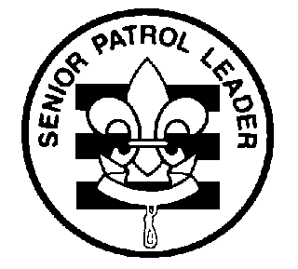
SENIOR PATROL LEADER

GENERAL INFORMATION

Type: Elected by the members of the troop
Term: 6 months
Reports to: Scoutmaster
Description: The Senior Patrol Leader is elected by the Scouts to represent them as the top junior leader in the troop.
Comments: The Senior Patrol Leader is the focal point of the troop. He needs to attend as close to all troop functions as possible.

QUALIFICATIONS

Age: 14 or over
Rank: 1st Class or higher
Experience: Previous service as ASPL
Attendance: 60% over previous 6 months

PERFORMANCE REQUIREMENTS
Training: You must attend the troop Junior Leader Training even if you have attended in the past.
Attendance: You are expected to attend 90% of all troop meetings and Patrol Leaders' Council meetings, and to be well represented at outings, and service projects. If your attendance is low, or if you have three (3) unexcused absences in a row, you can be removed from office.
Effort: You are expected to give this job your best effort.

SPECIFIC LEADERSHIP RESPONSIBILITIES
Runs all troop meetings, events, activities, and participates in the annual program planning conference.
Runs the Patrol Leader's Council meeting.
Appoints other troop junior leaders with the advice and counsel of the Scoutmaster.
Attends Troop Committee Meetings and reports on Troop.
Assists the Scoutmaster with Junior Leader Training.

GENERAL LEADERSHIP RESPONSIBILITIES
Uniform: Set the example by wearing your uniform correctly. This means that you will wear all of the parts of the troop uniform, shirttail tucked in, with all required badges in their correct locations.
Behavior: Set the example by living the Scout Oath and Law in your everyday life. Show Scout Spirit in everything you say and do.
Attendance: Set the example by being an active Scout. Be on-time for meetings and activities. You must call the Scoutmaster if you are not going to be at a meeting or if you suddenly have to miss an outing. You also need to make sure that the Assistant Senior Patrol Leader is ready to assume your responsibilities.

Troop 713
Leadership Position Description
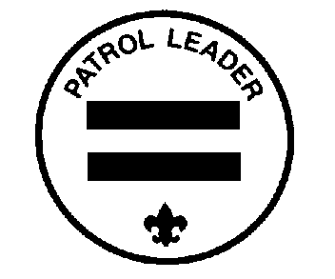
PATROL LEADER

GENERAL INFORMATION

Type: Appointed by the Scoutmaster and Senior Patrol Leader
Term: 6 months
Reports to: Assistant Senior Patrol Leader
Description: The Patrol Leader is the leader of his patrol. He represents his patrol on the Patrol Leader's Council.
Comments: The Patrol Leader may easily be the most important job in the troop. He has the closest contact with the patrol members and is in the perfect position to help and guide them. The Patrol Leaders, along with the Senior Patrol Leader and Assistant Senior Patrol Leader are the primary members of the Patrol Leaders' Council.

QUALIFICATIONS

Age: 12
Rank: 1st Class
Experience: Assistant Patrol Leader
Attendance: 60% over previous 6 months

PERFORMANCE REQUIREMENTS
Training: You must attend the troop Junior Leader Training even if you have attended in the past.
Attendance: You are expected to attend 90% of all troop meetings and Patrol Leaders' Council meetings. You must be well represented at Troop outings, and service projects. If your attendance is low, or if you have three (3) unexcused absences in a row, you can be removed from office.
Effort: You are expected to give this job your best effort.

SPECIFIC LEADERSHIP RESPONSIBILITIES
Works with and trains the Assistant Patrol Leader.

Represents the patrol on the Patrol Leader's Council
Plans and steers patrol meetings
Helps Scouts advance
Acts as the chief recruiter of new Scouts
Keeps patrol members informed
Knows what his patrol members and other leaders can do.
Provides leadership at campouts and activities
Keeps the Patrol Box, and makes sure it is in good order

GENERAL LEADERSHIP RESPONSIBILITIES
Uniform: Set the example by wearing your uniform correctly. This means that you will wear all of the parts of the troop uniform, shirttail tucked in, with all required badges in their correct locations.
Behavior: Set the example by living the Scout Oath and Law in your everyday life. Show Scout Spirit in everything you say and do.
Attendance: Set the example by being an active Scout. Be on-time for meetings and activities. You must call the Assistant Senior Patrol Leader if you are not going to be at a meeting or if you suddenly have to miss an outing. You also need to make sure that the Assistant Patrol Leader is ready to assume your responsibilities.

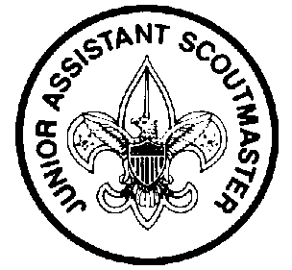
Troop 713
Leadership Position Description
JUNIOR ASSISTANT SCOUTMASTER

GENERAL INFORMATION

Type: Appointed by the Scoutmaster
Term: 1 year
Reports to: Scoutmaster
Description: The Junior Assistant Scoutmaster serves in the capacity of an Assistant Scoutmaster except where legal age and maturity are required. He must be at least 16 years old and not yet 18. He is appointed by the Scoutmaster because of his leadership ability.
Comments: In many cases the JASM has the same responsibilities as an Assistant Scoutmaster.

QUALIFICATIONS

Age: At least 16 years old
Rank: Eagle
Experience: Previous leadership positions
Attendance: 60% over the previous 6 months

PERFORMANCE REQUIREMENTS
Training: You must attend the troop Junior Leader Training even if you have attended in the past.
Attendance: You are expected to attend 60% of all troop meetings and Patrol Leaders' Council meetings, and be well represented at outings, and service projects. If your attendance is low, or if you have three (3) unexcused absences in a row, you can be removed from office.
Effort: You are expected to give this job your best effort.

SPECIFIC LEADERSHIP RESPONSIBILITIES
Functions as an Assistant Scoutmaster.
Performs duties as assigned by the Scoutmaster.

GENERAL LEADERSHIP RESPONSIBILITIES
Uniform: Set the example by wearing your uniform correctly. This means that you will wear all of the parts of the troop uniform, shirttail tucked in, with all required badges in their correct locations.
Behavior: Set the example by living the Scout Oath and Law in your everyday life. Show Scout Spirit in everything you say and do.
Attendance: Set the example by being an active Scout. Be on-time for meetings and activities.

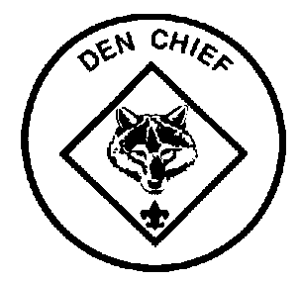
Troop 713
Leadership Position Description
DEN CHIEF

GENERAL INFORMATION

Type: Appointed by the Scoutmaster and Senior Patrol Leader
Term: 1 year
Reports to: Scoutmaster and Den Leader
Description: The Den Chief works with the Cub Scouts, Webelos Scouts, and Den and Pack Leaders in the Cub Scout pack.
Comments: The Den Chief provides a knowledge of games and Scout skills at Pack and Den meetings. The Den Chief is also a recruiter for the troop. A Den Chief can earn the Den Chief Service Award Cord which becomes a permanent part of his uniform. Wear it with pride! See the Den Chief Handbook for more details.

QUALIFICATIONS

Age: 12
Rank: 1st Class
Experience: usually a former cub scout
Attendance: 60% over previous 6 months

PERFORMANCE REQUIREMENTS
Training: You must attend the troop Junior Leader Training even if you have attended in the past.
Attendance: You are expected to attend 75% of all troop meetings and Patrol Leaders' Council meetings. You are expected to attend 75% of your assigned Den and Pack meetings and functions. If your attendance is low, or if you have three (3) unexcused absences in a row, you can be removed from office. You must inform the Den Leader if you will be absent.
Effort: You are expected to give this job your best effort.

SPECIFIC LEADERSHIP RESPONSIBILITIES

Knows the purposes of Cub Scouting
Helps Cub Scouts advance through Cub Scout ranks.
Is a friend to the boys in the Den.
Helps out at weekly Den meetings and monthly Pack meetings.
Meets with adult members of the Den, Pack, and Troop as necessary.
Encourages Cub Scouts to join a Boy Scout Troop upon graduation.
Expected when possible to earn the Den Chief Service Award

GENERAL LEADERSHIP RESPONSIBILITIES
Uniform: Set the example by wearing your uniform correctly. This means that you will wear all of the parts of the troop uniform, shirttail tucked in, with all required badges in their correct locations.
Behavior: Set the example by living the Scout Oath and Law in your everyday life. Show Scout Spirit in everything you say and do.
Attendance: Set the example by being an active Scout. Be on-time for meetings and activities. You must call the Pack or Den Leader if you are not going to be at a Pack or Den meeting.

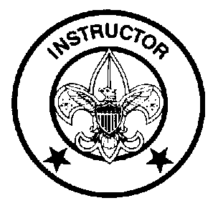
Troop 713
Leadership Position Description
INSTRUCTOR

GENERAL INFORMATION

Type: Appointed by the Scoutmaster and Senior Patrol Leader
Term: 6 months
Reports to: Scoutmaster
Description: The Instructor teaches specific Scouting skills.
Comments: The Instructor will work closely with Patrol Leaders, Troop Guides and Scouts. The Instructor should be competent to be able to teach a specific Scoutcraft skill needed for advancement. Examples could include First Aid, knots, orienteering, or lifesaving.

QUALIFICATIONS

Age: 13 or older
Rank: 1st Class or higher
Experience: none
Attendance: 60% over previous 6 months

PERFORMANCE REQUIREMENTS
Training: You must attend the troop Junior Leader Training even if you have attended in the past.
Attendance: You are expected to attend 60% of all troop meetings and Patrol Leaders' Council meetings, and be well represented at outings, and service projects. If your attendance is low, or if you have three (3) unexcused absences in a row, you can be removed from office.
Effort: You are expected to give this job your best effort.

SPECIFIC LEADERSHIP RESPONSIBILITIES
Teaches specific Scouting skills in troop and patrol gatherings.
Helps Senior Patrol Leader integrate scouting skills into Troop meeting program
Helps set up scouting skills activities at campouts – examples might be an orienteering course, building pioneering structures, or 1st aid drills.

GENERAL LEADERSHIP RESPONSIBILITIES
Uniform: Set the example by wearing your uniform correctly. This means that you will wear all of the parts of the troop uniform, shirttail tucked in, with all required badges in their correct locations.
Behavior: Set the example by living the Scout Oath and Law in your everyday life. Show Scout Spirit in everything you say and do.
Attendance: Set the example by being an active Scout. Be on-time for meetings and activities.

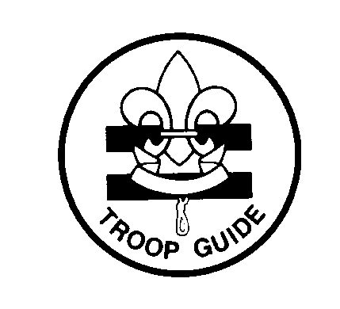
Troop 713
Leadership Position Description
TROOP GUIDE

GENERAL INFORMATION

Type: Appointed by the Scoutmaster and Senior Patrol Leader
Term: minimum 6 months
Reports to: Scoutmaster
Description: The Troop Guide works with new Scouts within his assigned Patrol. He helps them feel comfortable with scouting, and earn their First Class rank in their first year.
Comments: The first year as a Boy Scout is a critical time with new places, new people, new rules, and new activities. The Troop Guide is a friend to the new Scouts and makes first year fun and successful. This is an important position.

QUALIFICATIONS

Age: 13 or older
Rank: 1st Class or higher
Experience: none
Attendance: 60% over previous 6 months

PERFORMANCE REQUIREMENTS
Training: You must attend the troop Junior Leader Training even if you have attended in the past.
Attendance: You are expected to attend 90% of all troop meetings and Patrol Leaders' Council meetings, and be well represented at outings, and service projects. If your attendance is low, or if you have three (3) unexcused absences in a row, you can be removed from office.
Effort: You are expected to give this job your best effort.

SPECIFIC LEADERSHIP RESPONSIBILITIES

Sit with and assist the Patrol Leader at all meetings
Work with the patrol on advancement until, at a minimum, all the patrol members receive their First Class rank
Work with the boys that are already first class so they get at least 2 more merit badges
Meet at least 3 times (not at the troop meeting) to work on advancement and campout planning with the entire patrol
Attend at least 2 campouts with the patrol

GENERAL LEADERSHIP RESPONSIBILITIES
Uniform: Set the example by wearing your uniform correctly. This means that you will wear all of the parts of the troop uniform, shirttail tucked in, with all required badges in their correct locations.
Behavior: Set the example by living the Scout Oath and Law in your everyday life. Show Scout Spirit in everything you say and do.
Attendance: Set the example by being an active Scout. Be on-time for meetings and activities. You must call the Assistant Senior Patrol Leader if you are not going to be at a meeting or if you suddenly have to miss an outing.

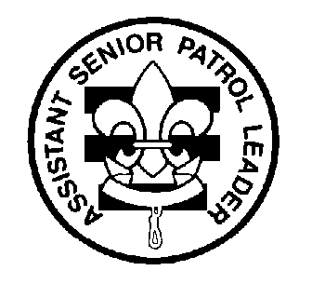
Troop 713
Leadership Position Description
ASSISTANT SENIOR PATROL LEADER

GENERAL INFORMATION

Type: Elected by the members of the Troop
Term: 6 months
Reports to: Senior Patrol Leader
Description: The Assistant Senior Patrol Leader is the second highest ranking patrol leader in the troop. The Assistant Senior Patrol Leader acts as the Senior Patrol Leader in the absence of the SPL or when called upon. He also provides leadership to other junior leaders in the troop.
Comments: The most important part of the ASPL position is his work with the other junior leaders. The ASPL should be familiar with the other positions and stay current with the work being done.

QUALIFICATIONS

Age: 14 and above
Rank: 1st Class or higher
Experience: none
Attendance: 60% over the previous 6 months

PERFORMANCE REQUIREMENTS
Training: You must attend the troop Junior Leader Training even if you have attended in the past.
Attendance: You are expected to attend 90% of all troop meetings and Patrol Leaders' Council meetings, and be well represented at outings, and service projects. If your attendance is low, or if you have three (3) unexcused absences in a row, you can be removed from office.
Effort: You are expected to give this job your best effort.

SPECIFIC LEADERSHIP RESPONSIBILITIES
Helps the Senior Patrol Leader lead meetings and activities.
Runs the troop in the absence of the Senior Patrol Leader.
Helps train and supervise the Troop Scribe, Quartermaster, Instructor, Librarian, Historian, and Chaplin Aide.
Serves as a member of the Patrol Leader's Council.

GENERAL LEADERSHIP RESPONSIBILITIES
Uniform: Set the example by wearing your uniform correctly. This means that you will wear all of the parts of the troop uniform, shirttail tucked in, with all required badges in their correct locations.
Behavior: Set the example by living the Scout Oath and Law in your everyday life. Show Scout Spirit in everything you say and do.
Attendance: Set the example by being an active Scout. Be on-time for meetings and activities. You must call the Senior Patrol Leader or Scoutmaster if you are not going to be at a meeting or if you suddenly have to miss an outing.

Troop 713
Leadership Position Description
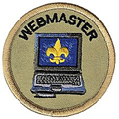
WEBMASTER

GENERAL INFORMATION
Type: Appointed by the Scoutmaster and Senior Patrol Leader
Term: 6 months
Reports to: Scoutmaster and Web Designer ASM
Description: The Webmaster maintains the Troop website, and ensures that it is relevant and up to date.
Comments: The Website is the focal point of information for Troop activities. It is an important data base and communications tool.

QUALIFICATIONS

Age: none
Rank: none
Experience: Familiarity with web site development
Attendance: 60% over previous 6 months

PERFORMANCE REQUIREMENTS
Training: You must attend the troop Junior Leader Training even if you have attended in the past.
Attendance: You are expected to attend 60% of all troop meetings and Patrol Leaders' Council meetings, and be well represented at outings, and service projects. If your attendance is low, or if you have three (3) unexcused absences in a row, you can be removed from office.
Effort: You are expected to give this job your best effort.

SPECIFIC LEADERSHIP RESPONSIBILITIES
The Webmaster is responsible for the troop website. He should work with the Web Designer adult leader to keep information on the web site relevant and up to date.
Makes sure the Calendar is current and correct and dates and information of upcoming events and activities are posted.
Encourages scouts to send in pictures of outings and events, and displays pictures of past activities.

GENERAL LEADERSHIP RESPONSIBILITIES
Uniform: Set the example by wearing your uniform correctly. This means that you will wear all of the parts of the troop uniform, shirttail tucked in, with all required badges in their correct locations.
Behavior: Set the example by living the Scout Oath and Law in your everyday life. Show Scout Spirit in everything you say and do.
Attendance: Set the example by being an active Scout. Be on-time for meetings and activities.

Troop 713
Leadership Position Description
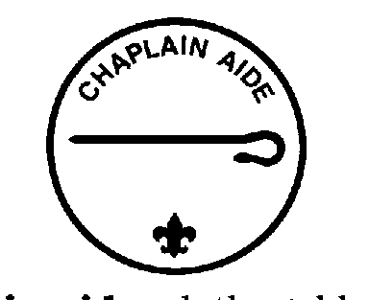
CHAPLIN AIDE

GENERAL INFORMATION

Type: Appointed by the Scoutmaster and Senior Patrol Leader
Term: 6 months
Reports to: Assistant Senior Patrol Leader
Description: The Chaplin Aide works with the Scoutmaster and the Troop Chaplin to meet the spiritual needs of Scouts in the troop. He also works to promote the religious awards program.
Comments: The Chaplin Aide prepares short inspirational observations for the start of Troop meetings, campouts and other functions.

QUALIFICATIONS

Age: none
Rank: none
Experience: none
Attendance: 60% over the previous 6 months

PERFORMANCE REQUIREMENTS
Training: You must attend the troop Junior Leader Training even if you have attended in the past.
Attendance: You are expected to attend 90% of all troop meetings, and Patrol Leaders' Council meetings, and be well represented at outings, and service projects. If your attendance is low, or if you have three unexcused absences in a row, you can be removed from office.
Effort: You are expected to give this job your best effort.

SPECIFIC LEADERSHIP RESPONSIBILITIES
Prepares a short inspirational thought for the beginning of each Troop meeting.
Informs Scouts about the religious emblem program for their faith.
Makes sure religious holidays are considered during troop program planning.
Helps plan for religious observance in troop activities, including grace at Troop meals.

GENERAL LEADERSHIP RESPONSIBILITIES
Uniform: Set the example by wearing your uniform correctly. This means that you will wear all of the parts of the troop uniform, shirttail tucked in, with all required badges in their correct locations.
Behavior: Set the example by living the Scout Oath and Law in your everyday life. Show Scout Spirit in everything you say and do.
Attendance: Set the example by being an active Scout. Be on-time for meetings and activities. You must call the Assistant Senior Patrol Leader if you are not going to be at a meeting or if you suddenly have to miss an outing. You also need to make sure that someone will assume your responsibilities.

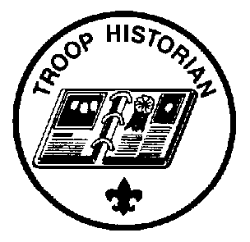
Troop 713
Leadership Position Description
TROOP HISTORIAN

GENERAL INFORMATION

Type: Appointed by the Scoutmaster and Senior Patrol Leader
Term: 6 months
Reports to: Assistant Senior Patrol Leader
Description: The Troop Historian keeps a historical record or scrapbook of troop activities.
Comments: The true value of a good Historian does not show up until years later. The Historian provides material for displays and presentations of current activities. In addition, the work of the Historian provides a link with the past.

QUALIFICATIONS

Age: none
Rank: none
Experience: none, but interest in photography and writing are helpful
Attendance: 60% over the previous 6 months

PERFORMANCE REQUIREMENTS
Training: You must attend the troop Junior Leader Training even if you have attended in the past.
Attendance: You are expected to attend 60% of all troop meetings and Patrol Leaders' Council meetings, and be well represented at outings, and service projects. If your attendance is low, or if you have three (3) unexcused absences in a row, you can be removed from office.
Effort: You are expected to give this job your best effort.

SPECIFIC LEADERSHIP RESPONSIBILITIES
Gathers pictures and facts about past troop activities and keeps them in a historical file or scrapbook.
Takes care of troop trophies, plaques, ribbons, and souvenirs of troop activities.
Keeps information about former members of the troop.
Aids adult leaders as needed in preparing articles for the local paper on Troop activities.

GENERAL LEADERSHIP RESPONSIBILITIES
Uniform: Set the example by wearing your uniform correctly. This means that you will wear all of the parts of the troop uniform, shirttail tucked in, with all required badges in their correct locations.
Behavior: Set the example by living the Scout Oath and Law in your everyday life. Show Scout Spirit in everything you say and do.
Attendance: Set the example by being an active Scout. Be on-time for meetings and activities.


Troop 713
Leadership Position Description
TROOP LIBRARIAN

GENERAL INFORMATION

Type: Appointed by the Scoutmaster and Senior Patrol Leader
Term: 6 months
Reports to: Assistant Senior Patrol Leader
Description: The Troop Librarian takes care of troop literature.
Comments: The library contains books of historical value as well as current materials. All together, the library is a troop resource. The Librarian manages this resource for the troop.

QUALIFICATIONS

Age: none
Rank: none
Experience: none
Attendance: 60% over the previous 6 months

PERFORMANCE REQUIREMENTS
Training: You must attend the troop Junior Leader Training even if you have attended in the past.
Attendance: You are expected to attend 60% of all troop meetings and Patrol Leaders' Council meetings, and be well represented at outings, and service projects. If your attendance is low, or if you have three (3) unexcused absences in a row, you can be removed from office.
Effort: You are expected to give this job your best effort.

SPECIFIC LEADERSHIP RESPONSIBILITIES

Sets up and takes care of troop library
Keeps records of books and pamphlets owned by the troop.
Adds new or replacement items as needed.
Keeps books and pamphlets available for borrowing.
Keeps a system for checking books and pamphlets in and out.
Follows up on late returns.

GENERAL LEADERSHIP RESPONSIBILITIES
Uniform: Set the example by wearing your uniform correctly. This means that you will wear all of the parts of the troop uniform, shirttail tucked in, with all required badges in their correct locations.
Behavior: Set the example by living the Scout Oath and Law in your everyday life. Show Scout Spirit in everything you say and do.
Attendance: Set the example by being an active Scout. Be on-time for meetings and activities. You must call the Assistant Senior Patrol Leader if you are not going to be at a meeting or if you suddenly have to miss an outing. You also need to make sure that someone will assume your responsibilities.

Troop 713
Leadership Position Description
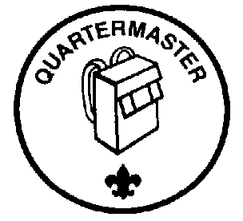
TROOP QUARTERMASTER

GENERAL INFORMATION

Type: Appointed by the Scoutmaster and Senior Patrol Leader
Term: 6 months
Reports to: Assistant Senior Patrol Leader
Description: The Troop Quartermaster keeps track of troop equipment and sees that it is in good working order. He is in charge of Troop T-shirts. He is responsible for the Troop flags.
Comments: The Quartermaster does most of his work around campouts. There are times when the Quartermaster has to be available to check equipment in and out.

QUALIFICATIONS

Age: none
Rank: none
Experience: none
Attendance: 60% over the previous six months

PERFORMANCE REQUIREMENTS
Training: You must attend the troop Junior Leader Training even if you have attended in the past.
Attendance: You are expected to attend 80% of all troop meetings and Patrol Leaders' Council meetings, and be well represented at outings, and service projects. If your attendance is low, or if you have three (3) unexcused absences in a row, you can be removed from office.
Effort: You are expected to give this job your best effort.

SPECIFIC LEADERSHIP RESPONSIBILITIES

Keeps records on patrol and troop equipment

Makes sure equipment is in good working condition
Issues equipment and makes sure it is returned in good condition

Makes suggestions for new or replacement items
Works with the Troop Committee member responsible for equipment
Is responsible for the US and Troop flags for meetings and ceremonies.
Is responsible to purchase and sell Troop T-shirts as needed

GENERAL LEADERSHIP RESPONSIBILITIES
Uniform: Set the example by wearing your uniform correctly. This means that you will wear all of the parts of the troop uniform, shirttail tucked in, with all required badges in their correct locations.
Behavior: Set the example by living the Scout Oath and Law in your everyday life. Show Scout Spirit in everything you say and do.
Attendance: Set the example by being an active Scout. Be on-time for meetings and activities. You must call the Assistant Senior Patrol Leader if you are not going to be at a meeting or if you suddenly have to miss an outing. You also need to make sure that someone will assume your responsibilities.

Troop 713
Leadership Position Description
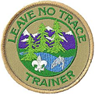
LEAVE NO TRACE TRAINER

GENERAL INFORMATION

Type: Appointed by the Scoutmaster and Senior Patrol Leader
Term: 6 months
Reports to: Assistant Senior Patrol Leader
Description: The Leave no Trace Trainer is responsible for the education of the Troop in the principals and practices of Leave no Trace.
Comments: The BSA is committed to Leave no Trace and it’s message of low impact on the environment.

QUALIFICATIONS

Age: 14
Rank: 1st class or above
Experience: Familiar with leave no trace principles and practices
Attendance: 60% over previous 6 months

PERFORMANCE REQUIREMENTS
Training: You must attend the troop Junior Leader Training even if you have attended in the past.
Attendance: You are expected to attend 60% of all troop meetings and be well represented at outings, and service projects. If your attendance is low, or if you have three (3) unexcused absences in a row, you can be removed from office.
Effort: You are expected to give this job your best effort.

SPECIFIC LEADERSHIP RESPONSIBILITIES
The Leave no Trace Trainer should actively take training in Leave no Trace ethics if available.
The Leave no Trace Trainer should earn his leave no trace award, and encourage other scouts from the Troop to do the same.
The Leave no Trace Trainer should give a presentation on Leave no Trace principals and practices to the Troop, and work with individual patrols to teach LNT for individual scout advancement purposes.
The Leave no Trace Trainer should encourage LNT on Troop campouts, and organize local environmental service projects that highlight the ethics of LNT.

GENERAL LEADERSHIP RESPONSIBILITIES
Uniform: Set the example by wearing your uniform correctly. This means that you will wear all of the parts of the troop uniform, shirttail tucked in, with all required badges in their correct locations.
Behavior: Set the example by living the Scout Oath and Law in your everyday life. Show Scout Spirit in everything you say and do.
Attendance: Set the example by being an active Scout. Be on-time for meetings and activities.

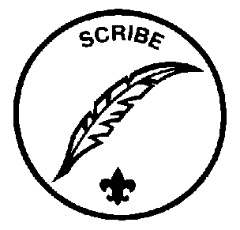
Troop 713
Leadership Position Description
TROOP SCRIBE

GENERAL INFORMATION

Type: Appointed by the Scoutmaster and Senior Patrol Leader
Term: 6 months
Reports to: Assistant Senior Patrol Leader
Description: The Scribe keeps the troop records. He records the activities of the Patrol Leaders' Council and keeps a record of Scout attendance at troop meetings. He also surveys the scouts for ideas on future events and service projects.
Comments: To be a good Scribe you need to attend nearly all troop and Patrol Leaders' Council meetings.

QUALIFICATIONS

Age: none
Rank: none
Experience: none
Attendance: 60% over the previous six months

PERFORMANCE REQUIREMENTS
Training: You must attend the troop Junior Leader Training even if you have attended in the past.
Attendance: You are expected to attend 80% of all troop meetings and Patrol Leaders' Council meetings, and be well represented at outings, and service projects. If your attendance is low, or if you have three (3) unexcused absences in a row, you can be removed from office.
Effort: You are expected to give this job your best effort.

SPECIFIC LEADERSHIP RESPONSIBILITIES

Attends and keeps a log of Patrol Leaders' Council meetings
Records Scout attendance at Troop meetings and works with the Troop Committee member responsible for records and attendance by providing an attendance record for each meeting.
Surveys the scouts on past and future events and activities to gauge what scouts want for future programming.

GENERAL LEADERSHIP RESPONSIBILITIES
Uniform: Set the example by wearing your uniform correctly. This means that you will wear all of the parts of the troop uniform, shirttail tucked in, with all required badges in their correct locations.
Behavior: Set the example by living the Scout Oath and Law in your everyday life. Show Scout Spirit in everything you say and do.
Attendance: Set the example by being an active Scout. Be on-time for meetings and activities. You must call the Assistant Senior Patrol Leader if you are not going to be at a meeting or if you suddenly have to miss an outing. You also need to make sure that someone will assume your responsibilities.

Troop 713
Leadership Position Description
TROOP COOKING INSTRUCTOR

GENERAL INFORMATION

Type: Appointed by the Scoutmaster and Senior Patrol Leader
Term: 6 months
Reports to: Scoutmaster
Description: The Instructor teaches specific Scouting Cooking skills.

QUALIFICATIONS

Age: none
Rank: none
Experience: Cooking Merit Badge
Attendance: 60% over the previous six months

PERFORMANCE REQUIREMENTS
Training: You must attend the troop Junior Leader Training even if you have attended in the past.
Attendance: You are expected to attend 80% of all troop meetings, and be well represented at outings, and service projects. If your attendance is low, or if you have three (3) unexcused absences in a row, you can be removed from office.
Effort: You are expected to give this job your best effort.

SPECIFIC LEADERSHIP RESPONSIBILITIES
Assist other Scouts with the cooking requirements for Tenderfoot, 2nd Class, and 1st Class ranks.
Assist other Scouts who are working on their Cooking merit badge and work with the Cooking merit badge instructor.
On campouts, encourage others to experiment with different recipes and cooking techniques by handing out samples of your cooking.
Review and provide guidance on patrol menus for campouts.
Promote proper sanitary procedures for food preparation on campouts.
Present Cooking Tips at Troop Meetings.
Keep notebook updated.
Pass this notebook on to the next Cooking Instructor.
Assist in the next Cooking Instructor’s transition.

GENERAL LEADERSHIP RESPONSIBILITIES
Uniform: Set the example by wearing your uniform correctly. This means that you will wear all of the parts of the troop uniform, shirttail tucked in, with all required badges in their correct locations.
Behavior: Set the example by living the Scout Oath and Law in your everyday life. Show Scout Spirit in everything you say and do.
Attendance: Set the example by being an active Scout. Be on-time for meetings and activities. You must call the Assistant Senior Patrol Leader if you are not going to be at a meeting or if you suddenly have to miss an outing. You also need to make sure that someone will assume your responsibilities.

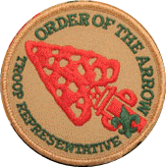
Troop 713
Leadership Position Description

OA Representative

GENERAL INFORMATION

Type: Appointed by the Scoutmaster and Senior Patrol Leader
Term: 6 months
Reports to: Assistant Senior Patrol Leader
Description: The Order of the Arrow Troop representative is a youth serving his Troop
as the primary liaison to the Troop’s Chapter and Lodge.

PERFORMANCE REQUIREMENTS
Training: You must attend the troop Junior Leader Training even if you have attended in the past.
Attendance: You are expected to attend 80% of all troop meetings, and be well represented at outings, and service projects. If your attendance is low, or if you have three (3) unexcused absences in a row, you can be removed from office.
Effort: You are expected to give this job your best effort.

SPECIFIC LEADERSHIP RESPONSIBILITIES
Attend troop chapter or lodge meetings regularly as a youth representative of the Troop to the Order
Serves as a two-way communication link between the troop and the lodge or chapter.
Arranges with the lodge or chapter election team to conduct an annual Order of the Arrow election for the troop at a time approved by the Patrol leaders Council.
Arranges with the lodge or chapter for at least one camp presentation visit to the unit annually.
Makes at least one high adventure presentation to the troop , to include OA programs annually.
As requested by the SPL, participates in Troop Court of Honors by recognizing: high adventure participation of troop members, induction of new OA members, changes in OA honors of troop members, leadership of troop members and other appropriate activities.

GENERAL LEADERSHIP RESPONSIBILITIES
Uniform: Set the example by wearing your uniform correctly. This means that you will wear all of the parts of the troop uniform, shirttail tucked in, with all required badges in their correct locations.
Behavior: Set the example by living the Scout Oath and Law in your everyday life. Show Scout Spirit in everything you say and do.
Attendance: Set the example by being an active Scout. Be on-time for meetings and activities. You must call the Assistant Senior Patrol Leader if you are not going to be at a meeting or if you suddenly have to miss an outing. You also need to make sure that someone will assume your responsibilities.

Troop 713
Leadership Position Application
Your Name: Age:
Current Rank:
Current Position: Previous Positions:
Attendance (6 months): (get from Troop Scribe records)
List your first three choices
1st Choice | 2nd Choice | 3rd Choice
For your first choice, use this space to tell why you want this job, how you would do the job, and why you are the best choice for this position.
Scout's Agreement
I have read the job descriptions for these positions. I understand the duties and responsibilities and if selected will carry them out to the best of my ability.

(signature) (date)
Parent's Support Agreement
I agree with the commitment my son is making. I promise to support him in attending training, troop meetings, and troop activities as well as with encouragement at home. I realize that once selected his presence is necessary for the smooth functioning of the troop.

(signature) (date)

